1. GET- запрос https://petstore.swagger.io/v2/store/inventory

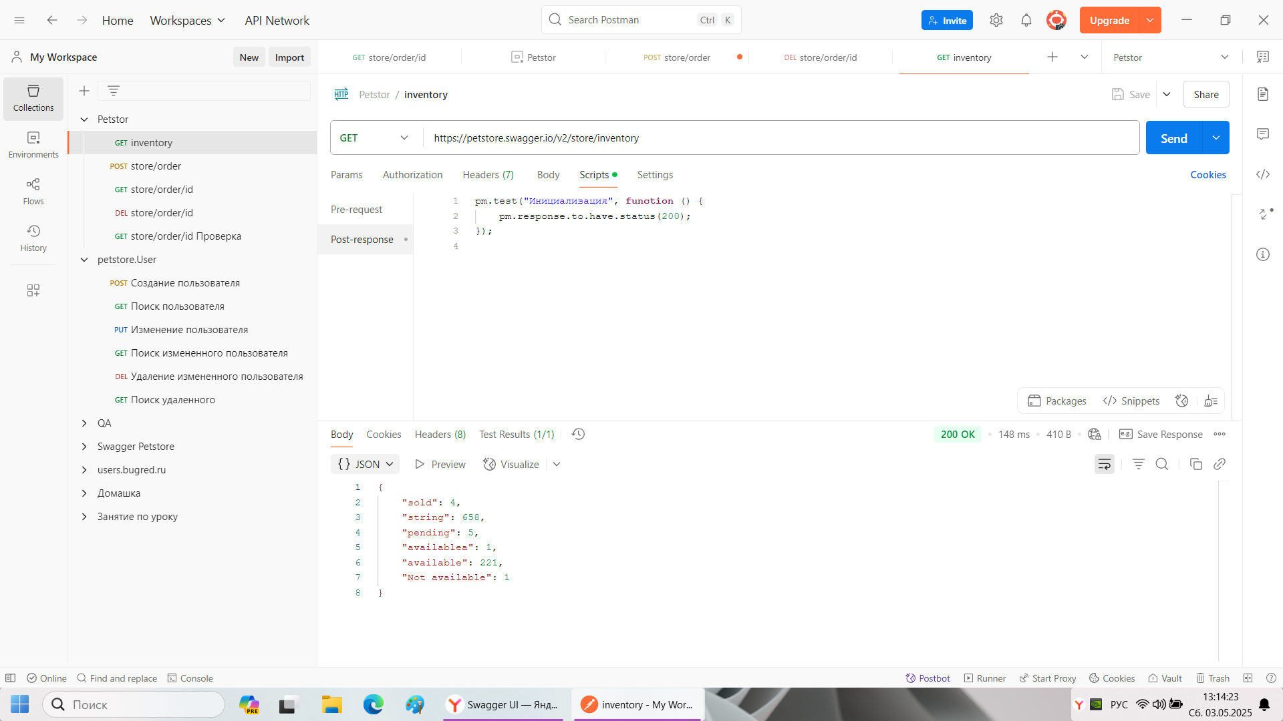

1. POST - запрос. <https://petstore.swagger.io/v2/store/order>

Тело запроса.

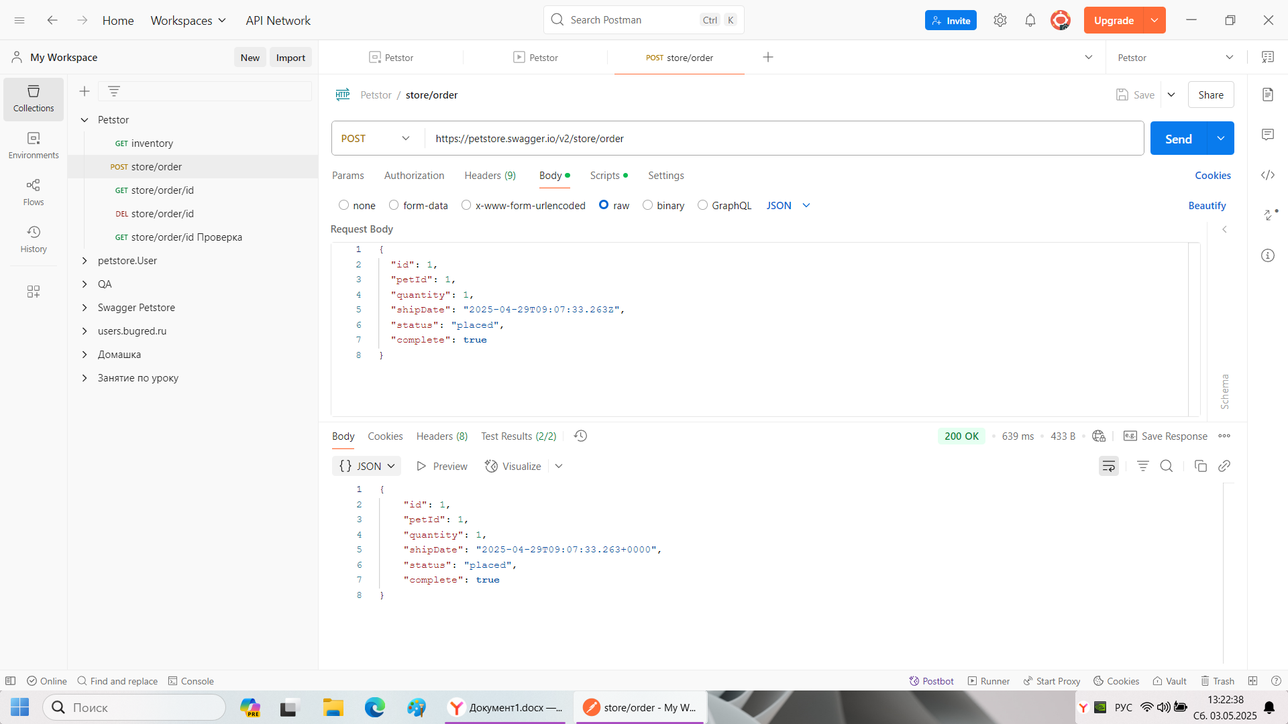

2.1) Post – respons со Snippets



1. GET-запрос. <https://petstore.swagger.io/v2/store/order/{{ID>}}

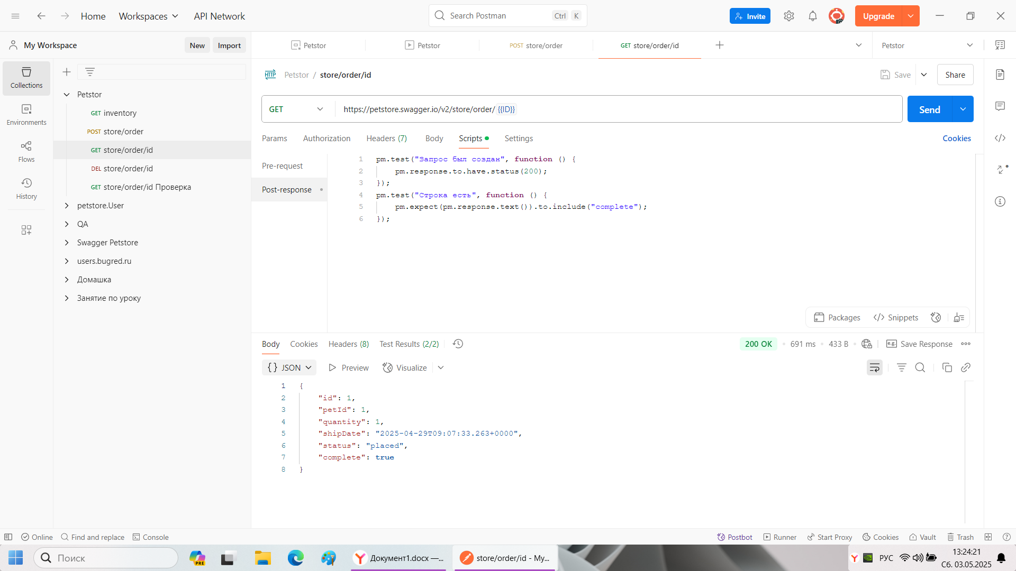

1. DEL - запрос. <https://petstore.swagger.io/v2/store/order/{{ID>}}

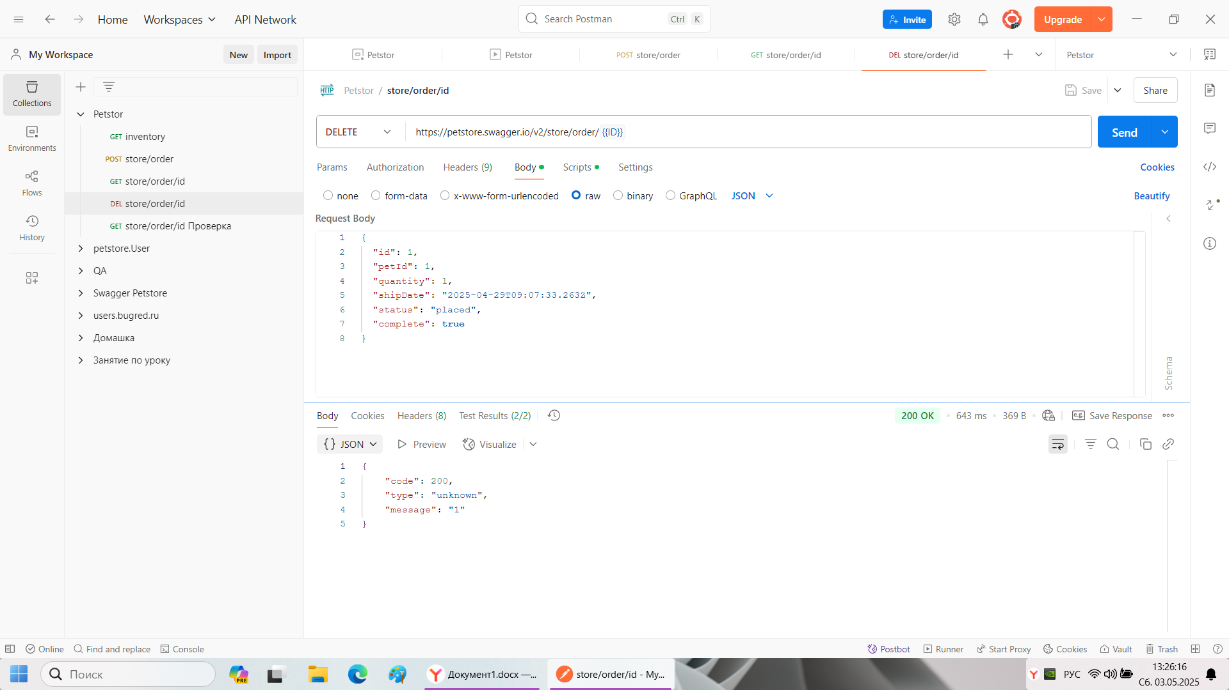

4.1) Post – respons со Snippets

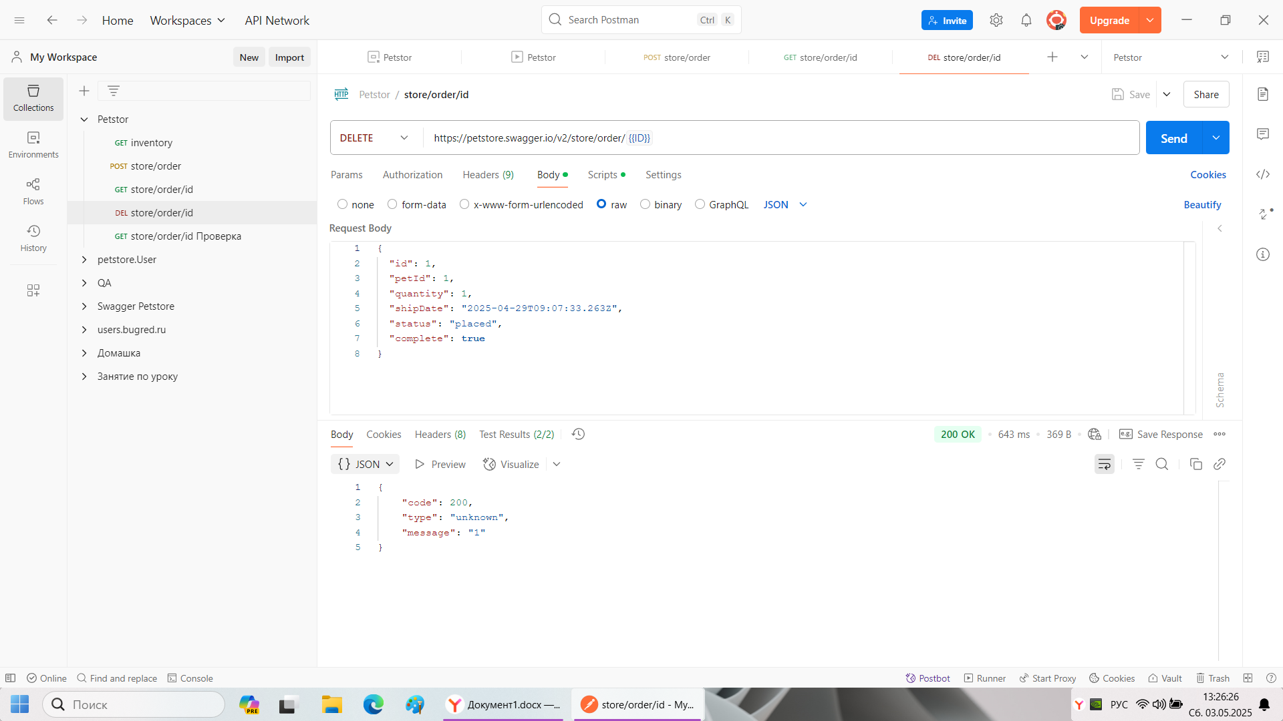

1. GET - запрос . <https://petstore.swagger.io/v2/store/order/{{ID>}}

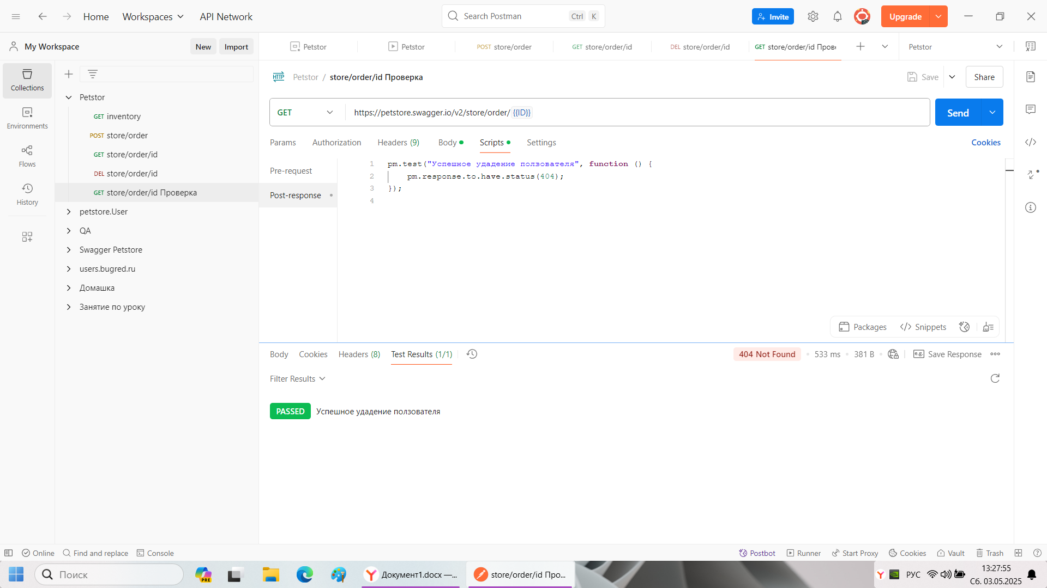

1. RUN-result

